Test Case/s to be automated

Contents

Pay Billing export to file 1

Pre-requisites 1

Test setup: 1

Test case 1: Export data to file 2

# Pay Billing export to file

## Pre-requisites

Ensure you are working and pushing to your own branch

## Test setup:

Navigate to <http://demo.guru99.com/telecom/index.html>

Select Pay Billing

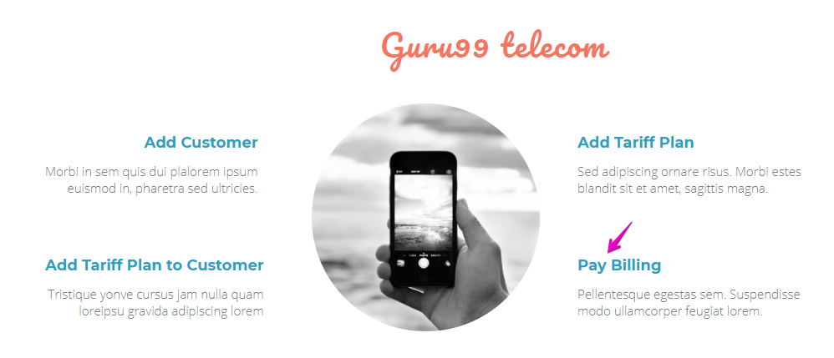

Assert that the Heading is Guru 99 Telcom and Pay Billing

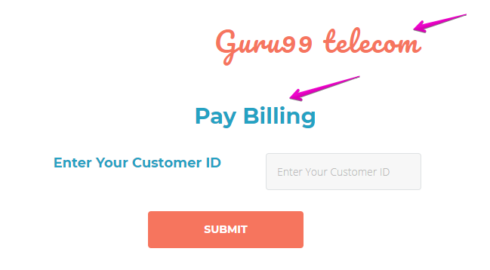

## Test case 1: Export data to file

Create a customer who has done a credit check



Enter the customer id and submit

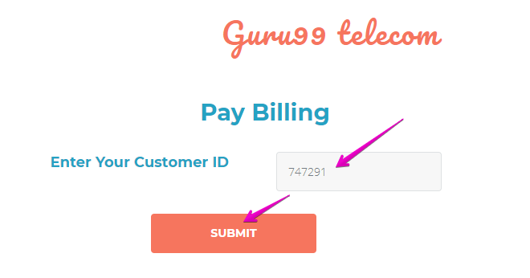

Expected Result:

Customer id displayed correctly

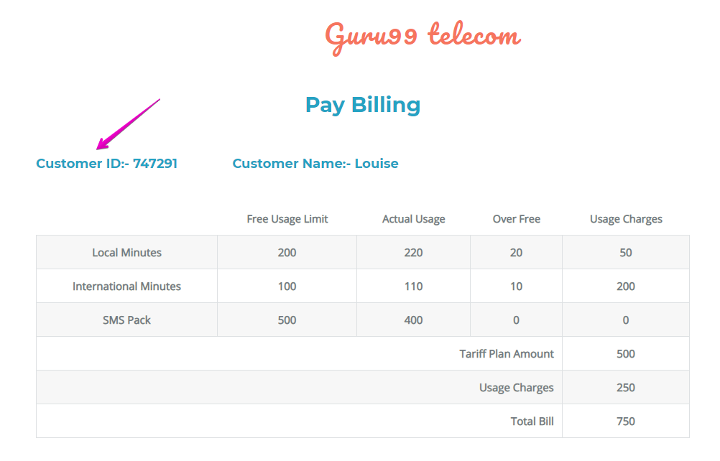

Export the data above to a file (csv or txt)